Which Chemistry at Normandale Community College is for you?
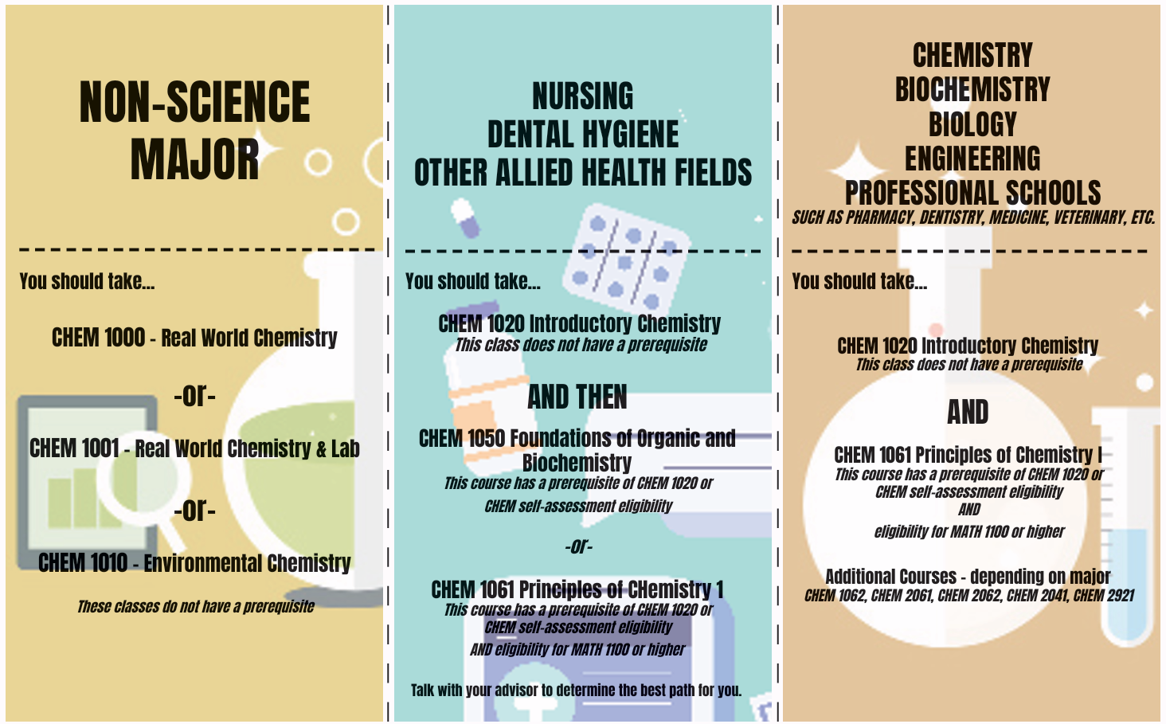

Chemistry Self-Assessment Information 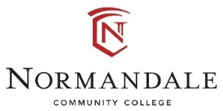

What is the Chemistry Self-Assessment Survey?
The Chemistry Self-Assessment is a tool for students to use to determine if their previous chemistry course(s) are sufficient to register directly in Foundations of Organic and Biochemistry (CHEM 1050) or Principles of Chemistry (CHEM 1061) without first completing Introductory Chemistry (CHEM 1020).
To register for CHEM 1061, you will also need to meet the Mathematics portion of the prerequisite requirements, which is eligibility for MATH 1100 or higher. Your current Math placement is available on the Course Placement page in your eServices.

Who should consider taking the Chemistry Self-Assessment Survey?
Students who have previously succeeded in a rigorous chemistry course are the best candidates for the self-assessment. Such a course might have been taken in high school or might be a non-majors college chemistry course. If you have previously taken an introductory chemistry at another campus, you should first determine if it transfers in to Normandale as CHEM 1020. If it does not, you can then use the self-assessment to determine if it sufficiently prepared you for CHEM 1050 or CHEM 1061.

Are there resources to help me review before taking the self-assessment?
Yes! There are many free chemistry review sites available online. Here are a few options:
- Introductory, Conceptual, and GOB Chemistry (free online textbooks)
- Chemistry: High School (requires free registration)
- Advanced Diploma in High School Chemistry (requires free registration)
- Chemistry review at Khan Academy (some materials available without login)

Where do I find the Chemistry self-assessment?
Click here: Chemistry Self-Assessment Survey

What will happen after I submit my self-assessment survey?
Your survey will be sent to the Records department for review. Please allow 2- 4 days for them to process your survey and update your student record.

Need guidance?
Talk to an academic advisor! If you are unsure about the best way to move forward, it’s time to see an advisor. Students who are pursuing competitive allied health programs, such as Nursing or Dental Hygiene, may want to complete CHEM 1020 to better prepare themselves to be successful in CHEM 1050. Additionally, completion of an additional science course such as CHEM 1020 is scored favorably on the dental hygiene application. More information can be found at www.normandale.edu/advising

