Emergency Evacuation/Severe Weather Plan for Students with Disabilities
In the event of an emergency alarm is sounded in any Normandale Community College building, it is important each person understands where to go and what to do to ensure a safe and timely campus evacuation.

Faculty Members
Students who have a mobility disability or vision loss will have evacuation information designated on their OSD accommodation plan that you receive at the beginning of each semester. In an emergency evacuation, stay with students in need, and ask them if they have a Personal Safety Plan arranged with the Public Safety Office or how you can best be of assistance during the evacuation procedure.

Students
Normandale’s Department of Public Safety offers students with disabilities the opportunity each semester to develop a Personal Safety Plan that may include the following safety interventions:
- A one-on-one meeting with Public Safety to discuss specific needs of the individual during an emergency.
- Campus maps of the areas the student frequents such as their classroom, study areas, or hangouts.
- Review of safety equipment that may be available to assist them in an emergency.
- A tour of evacuation routes, plus advice and tips for staying safe in an emergency on campus.
- Public Safety can be contacted at extension 555, 952-358-8280, or call 911 for assistance.

Here are some basic emergency guidelines that can help in an emergency:
- In the event of a fire, if possible, exit the building. If that is not feasible, we suggest three options:
- Relocate to another building on campus to allow fire personal an opportunity to contain and extinguish the fire.
- Have someone help you utilize an evacuation chair (see Evacuation Chair Section for locations)
- If either the two statements above are not feasible, get to the safest location possible and have a person that can exit the building inform fire personal where you are located, so additional help may be sent
- Never use elevators in a fire. Most buildings on campus have a ground floor exit easily accessible, and those that do not are equipped with an evacuation chair that can be used to safety bring students down stairs who may have difficulty doing so on their own. Designated safe areas have directions, maps, an analog phone, and space for at least two wheelchairs.
- The campus is protected by a fire sprinkler protection system. Smoke from a fire can be dangerous, so if possible, stay low and go.
- Severe weather shelter areas are usually on the lowest level of each building. Getting to one should be a priority. However, if time does not allow, bathrooms, closets, and interior windowless rooms are also good options.
- Never hesitate to request help from Normandale staff. If they cannot assist, they may organize others who can.

Evacuation Exits
- The first floors of all buildings have outdoor access.
- All areas on the second floor of the inner ring corridors have access to the outdoor courtyard area.

Evacuation Chair Locations
Below is a list of where each evacuation chair is located on campus:
- Activities: Located at the top of staircase A2 which is near the elevator mechanical room A2579 or near the 2nd floor Activities elevator.
- College Services: All Evac Chairs are located on the 3rd floor of College Services.
  - One is located in stairwell C1 (which is across from Communications Dept. Breakout rooms to C3003-C3008).
  - The next chair is located at the top of staircase C2 (which is across from classroom C3060).
  - Finally, the last is located at the top of staircase C3 (which is next to the College Services elevator or adjacent to Faculty Offices C3101).
- Fine Arts: At the top of the staircase of F1 (which is next to the main doors of the Fine Arts building (door #6) or near classroom C2297).
- Kopp Student Center: Located in stairwell K1 which is adjacent to the fireplace, near the southwest corner of the lounge area close to the windows.
- Partnership: It is inside stairwell P4; which is in the central part of the building, next to the women’s restroom P2811.
- Science: At the second level of Science next to stairwell S4, which is near the small lounging area S2382 or office S2381.
- Library: Located on the 3rd floor of the library. The chair is located on the southside of the 3rd floor in between offices L3712 & L3710.

Severe Weather
If you are NOT located on the ground level of a building, use the above rescue areas for severe weather, or if time does not allow, bathrooms, closets, and interior windowless rooms are also good options. Please seek out the following exceptions in the event of severe weather:
- Activities: hallway between A2554 and A2556
- Kopp Student Center: S1392 restrooms at the start of hallway to Activities Building, or go near to A1500 (gym)
- Library: hallway near L2756-L2760
- Science: restrooms near S2384
- Partnership Center: classrooms P1838, P1808, P2842, or P2802

Figure 1. Map of Evacuation Chair and Tornado Shelter Locations on Second Floor
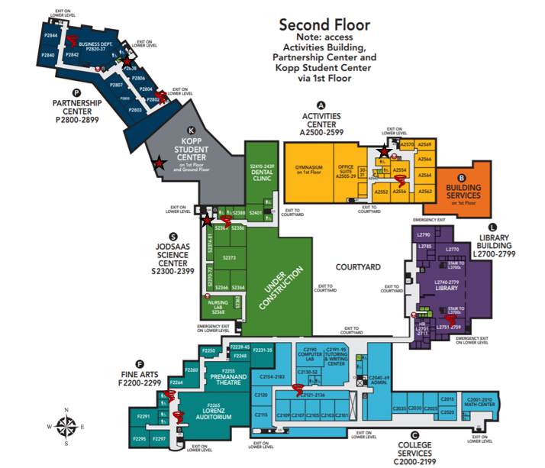
Key
 | Evacuation Chair Locations
 | Tornado Shelters

Figure 2. Map of Evacuation Chair and Tornado Shelter Locations on Third Floor
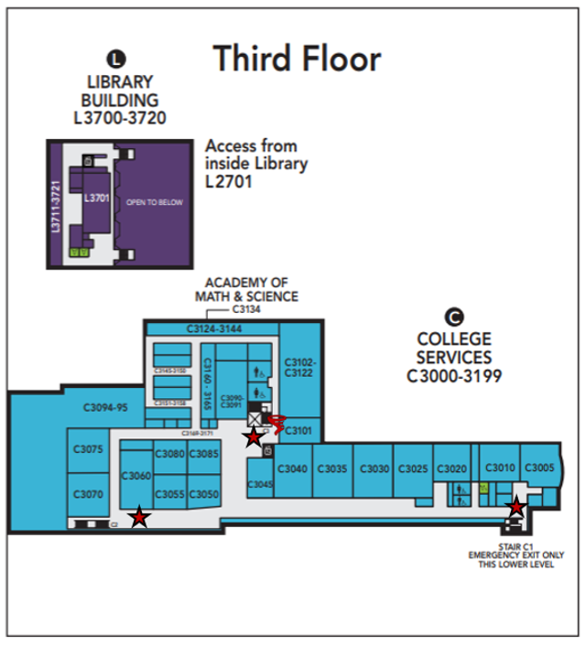
Key
Evacuation Chair Locations
Tornado Shelters

www.normandale.edu/_files/documents/osd/EvacuationPlan.docx Updated 7/1/26

